

|  |
| --- |
|  |
| Go Tickets |
| System Design |
| By – Moumi Kumar, Miloni Gada, Monisha Gopal & Kalyani A |

|  |  |
| --- | --- |
| *Table of Contents*  Introduction3  Problem Statement3  Business Description4  System Request7  *Business Need7*  Business Requirement7  Business Value7  Special Issues Or constraints7  Scope Of the system8  *Gantt Chart9*  Functional Requirements10  *Non-Functional Requirements12*  *Use Cases13*  *Context Diagram25*  ***Data Flow Diagrams (Level 0)26***  ***Data Flow Diagrams (Level 1)27***  *Data Dictionary36*  ***User Interface Design Prototype37***  *Program Structure Chart53*  *Future Scope for Improvement 57*  *Conclusion 58* |  |
|  |
|  |

|  |  |
| --- | --- |
|  | Decorative |
| Introductionproblem statement In these fast-paced overly competitive times, we are gradually shifting to a digital age. We read the news online, we shop online, we order food online and so on. But why stop there? Why not extend this to other sectors too?  Go Tickets is one such online platform that enables the users to view listing of events/shows online, based on their location, the type of show they’re interested in, duration of the event etc. This helps the users to choose amongst an array of events happening around them, book tickets for the same in advance, get discounts and get an overall simplified user experience.  But we don’t stop there. Along with the customers, we have other end users too - they are our event partners. From a local event like a stand-up comedy show to multi-national events like music concerts, every event deserves awareness and recognition. In order to make sure that the local art doesn’t get lost in the pool of competition, our website showcases them on the dashboard to catch user’s attention. The event partners benefit from our platform due to the large customer footprint, ease of booking, systematic payment portals etc. by listing their events on our page.  To sum it up, we make event/show listing and booking more comprehensive and user-friendly. |
| Business Description With the return of offline events post COVID-19 lockdown, lack of awareness about these events is leading to losses for event business, and even more so, willing customers aren’t able to attend them. To solve this problem, we came up with the idea of creating a platform that lists down all these events on a common platform, where a customer can view events around them and businesses can post relevant & necessary information about their events. We hope to bridge the gap between supply and demand that is created by miscommunication & lack of knowledge.  Go Tickets is an online ticketing facility. Go Tickets provides services in the form of website for movies, plays, events and sports tickets. Apart from being an online ticketing portal, Go Tickets offers information about upcoming movies and events, show timings, venue details and artist bios.  User opens the website and searches for the category of interest for the event. System will display catalogue of categories. Once the category is chosen, the events associated with the category will be extracted from events data store and displayed according to the user selection.  User selects an event. For example, a movie. System will extract data from events data store according to the movie name and display all the venues and show timings playing the movie.  User will select the preferred venue and show timing for the movie. The system will display an arrangement of seats available from Reservation data store. Based on the seats available user will select the desired seats; system will highlight the selected seats. Once the selection is satisfactory for the user, User can add their preferred seats and put it into the virtual cart. This process can repeat.  On clicking the cart selecting next, User will be asked either to login or create an account. Once the user logs in or creates an account he/she will be redirected to the payment information page.  System calculates the total order price by adding the ticket price, tax cost for the region and quantity  In the payment information page, the system displays the total price for the order by calculating order price will be calculated based on discounts, quantity and region wise tax (extracted from tax data store which has static information about taxes at various locations). System then provides payment options for the user. Once the user selects the mode of payment, system will generate a payment request and. and prompt the user to enter payment details.  System verifies the payment details and generates the payment order receipt and stores it in order data store. System will also generate a unique ticket along with event id in the form of a barcode and email it to the customer by extracting customer details from customer data store. User Roles To understand each user’s flow, ­we separate it into 3 categories role wise:  **A.** **Admin** - Upon logging in, the admin can view the dashboard that has event requests. The admin ensures that the event is in compliance with the policies of the company **Go Tickets**. Once the event reviewing is done, the admin updates the event data store with the status “approved or disapproved”. The system notifies the event EP of this update.  **B.** **Event Partner** - Upon logging in, the event partner (EP) can view a dashboard with their registered events. Every EP has to pay a yearly subscription to register themselves on the website. The subscriptions vary depending on the number of events an EP is allowed to post. The subscriptions are stored in a Static subscription table. Once the EP provides their CC details, the system sends them to the Credit Card Clearing House for approval. Upon approval, the EP is notified of successful payment and an order receipt is generated, that is stored in anOrder data store. Once the registration is complete, the EP can submit their event request to the system admin by filling some key details about the event like event duration, genre, type, description, list of actors, directors, producers etc. Upon the system admins approves the event request, the event is ready to be displayed on the website dashboard.  **C.** **Customer** - Upon logging in, the customer can view all events on the dashboard. The website displays events based on the city of the customer; however, the customer can change their city preferences to view events in other places. The customer gets to view events based on the time, type of event like movie, stand-up comedy, theatre, exhibitions etc. The website displays the ratings for each. The customer selects an event, within an event, he/she enters the event time and venue, and then finally selects his/her preferred seats and adds it to their cart. All these options are displayed to the user for selection. The user must select at least one ticket to proceed further. The website then displays a menu of food & beverages available at the venue for that event & time. The user chooses (optional) one or more food/beverages and adds it to the cart with event tickets. During the above selections, if at any point, the event/ticket/food become unavailable, the system notifies the customer of the same and provides them with the best alternative. The system also notifies the food/beverage vendor manager with the out-of-stock items. The user can approve (or disapprove) the new suggestion and the cart is updated. Finally, the user is prompted to pay for the order value. The order values consist of cart value, tax value and discount value thereby displaying the sum total to the user. The tax value is stored in a static tax data store where the tax is calculated based on the city. The discount value is obtained from the discount data store where discount is calculated based on the order frequency of the user. Once the user provides their CC details, the system sends them to the Credit Card Clearing House for approval. Upon approval, the user is notified of successful payment and an order receipt. The order is recorded in the order data store. The system updates the event, tickets and food/beverages data store with the sold items. Post event, the system prompts the user to rate the event on a scale of 1 to 5. The user input is stored in the ratings data store. The event ratings get calculated based on this user input and is displayed on the event dashboard. |
| A person standing in front of a brick wall with notes |
|  |

|  |
| --- |
| **System Request- Event Ticket Booking Information System.** |
| **Project Sponsor:** GoTickets.com, CEO. |
| **Business Need:** Project has been initiated to provide information and services about various events happening across the country and provide a one stop portal for all events’ ticketing needs, enabling scheduling according to the geographic locations, time preferences, category, price and so on. A user can either host an event or choose to be a consumer for an event. |
| **Business Requirements:** Using the website or application, customers will be able to search for and purchase event ticket/s, along with food/beverages. The specific functionality that the system should have includes the following:  1) Search and browse events based on categories, title, locations(city), timings, price and rating etc.  2) Check the availability of the event based on user search. 3) Enable users to book the tickets for the event.  4) Allow users to book food/beverages along with the booking of tickets. 5) Get payment from the user and provide order confirmation for the same. 6) Request user to provide feedback post event. 7) Get event details from the Event Partner. 8) Ability to create an event on the website. 9) Allowing the admin to approve/disapprove newly created events. |
|  |
|  |
|  |
|  |
|  |
|  |
| **Business Value:** We expect that Go Tickets will increase sales by enabling existing customers to book an event from a wide variety of events’ list and reaching new customers by practicing creative marketing over various platforms. With efficient ticket & food inventory management and lesser event booking failures, customer satisfaction will increase. Conservative estimates of tangible value to the company include the following:  1) $350,000 in sales from booking events.  2) $100,000 in increased customer satisfaction due to efficient inventory management  3) $100,000 additional revenue is generated from the discounts offered. 4) By delivering a one stop solution for all the ticketing needs, not only does it promote time efficiency but generates $200,000 revenue. |  |
|  |
|  |
|  |
| **Special Issues or Constraints:** 1) There is a discussion over how to incorporate the web traffic of users who are just there to browse and not register or create accounts. 2) Because customers have access to various other websites where they can browse and book events from, we need to bring this system to market as soon as possible so we don't lose business.  3) The current patrons have been asking for worldwide ticketing facilities, we need to provide this service to avoid competition, thereby resulting in loss of business. |  |
|  |
|  |
|  |

### Scope of the system

Go Tickets has two primary users:

Customer: Our system enables them to view events/shows online and book tickets for the same. The customer can additionally order food/beverages online along with the event ticket booking. We enable the customers to provide feedback for the events they view and we offer discounts to our regular customers.

Event partner: Our system enables them to list their events/ shows along with the description onto our page. They are charged annually for the subscription they prefer and provided by user feedback for their events.

|  |  |  |
| --- | --- | --- |
|  |  | Decorative |
|  |  | GanTt Chart |
|  |

|  |  |
| --- | --- |
|  | Decorative |
| Functional Requirements |
| |  |  |  |  |  |  |  |  |  |  |  |  |  |  |  |  |  |  |  |  |  |  |  |  |  |  |  | | --- | --- | --- | --- | --- | --- | --- | --- | --- | --- | --- | --- | --- | --- | --- | --- | --- | --- | --- | --- | --- | --- | --- | --- | --- | --- | --- | | **Functional Requirements: Process oriented Requirements** | | | | | | | | | | | | | | | | | | | | | | | | |  | | | **1. Create an account, Search & browse & select (All):** | | | | | | | | | | | | | | | | | | | | | | | | |  | | | 1.1 The system will allow different users to register on the web/app based on their roles - admin, customer or event partners. | | | | | | | | | | | | | | | | | | | | | | | | |  | | | 1.2 The system will display events based on title, category, location, price etc. | | | | | | | | | | | | | | | | | | | | | | | | |  | | | 1.3 The system will allow the user to search and browse for the event based on the title, genre, time, language of the event and format (2D,3D, IMAX 2D, Online Streaming, Outdoor events etc.) | | | | | | | | | | | | | | | | | | | | | | | | |  | | | 1.4 The system will allow the user to select one show/event at a time from the dashboard based on place, time, language of the movie, genre and format (2D,3D, IMAX2D). | | | | | | | | | | | | | | | | | | | | | | | | |  | | | 1.5 The system will allow the user to select one or more seat preferences from the seating arrangements. | | | | | | | | | | | | | | | | | | | | | | | | |  | | | 1.6 The system will allow the user to select one or more items from the “food & beverages” menu for pre-booking meals. | | | | | | | | | | | | | | | | | | | | | | | | |  | | |  |  | |  |  | |  | |  | |  | |  | |  | |  |  | |  | |  | | | |  | | | **2. Order Fulfilment:** | | | | | | | | | | | | | | | | | | | | | | | | |  | | | 2.1 The system will check the event data store and food menu data store to see if the items can be fulfilled. | | | | | | | | | | | | | | | | | | | | | | | | |  | | | 2.2 The system will send a notification for an unfulfilled event/ticket/food/beverages list to the customer. | | | | | | | | | | | | | | | | | | | | | | | | |  | | | 2.3 The System will revise the order to reflect only the available items in case of any non-fulfilment. | | | | | | | | | | | | | | | | | | | | | | | | |  | | | 2.4   If the revision of order is acceptable, the customer responds with an approval for the revised order. | | | | | | | | | | | | | | | | | | | | | | | | |  | | | 2.5 The system will send a notification for an unfulfilled event/ticket/food/beverage to the event and food inventory manager. | | | | | | | | | | | | | | | | | | | | | | | | |  | | | **3. Promotions/Discounts (customer):** | | | | | | | | | | | | | | | | | | | | | | | | |  | | | 3.1 The system will check the order datastore to check the customer order frequency. | | | | | | | | | | | | | | | | | | | | | | | | |  | | | 3.2 The system will check the promotions datastore to fetch the discount amount based on the booking frequency. | | | | | | | | | | | | | | | | | | | | | | | | |  | | | 3.3 The system will check the promotions datastore to fetch the promotional codes based on the booking frequency. | | | | | | | | | | | | | | | | | | | | | | | | |  | | | **4. Payment and order confirmation (customer):** | | | | | | | | | | | | | | | | | | | | | | | | |  | | | 4.1 The system will calculate the cart amount for the user selection. | | | | | | | | | | | | | | | | | | | | | | | | |  | | | 4.2 The system will calculate tax based on the city (where the event is based) referring to the tax data store. | | | | | | | | | | | | | | | | | | | | | | | | |  | | | 4.3 The system will calculate the total order amount based on the tax, promotions (discounts) and cart value. | | | | | | | | | | | | | | | | | | | | | | | | |  | | | 4.4 The system will request the user to provide their credit card details in the payment gateway. | | | | | | | | | | | | | | | | | | | | | | | | |  | | | 4.5 The system will route these details to the Credit Card Clearing House for verification. | | | | | | | | | | | | | | | | | | | | | | | | |  | | | 4.6 Upon verification and payment confirmation, the system generates an order receipt for the customer. | | | | | | | | | | | | | | | | | | | | | | | | |  | | | **5. Event and food inventory update:** | | | | | | | | | | | | | | | | | | | | | | | | |  | | | 5.1 Upon generating the order receipt, the system will update the ticketing system with sold items. | | | | | | | | | | | | | | | | | | | | | | | | |  | | | 5.2 The system will update the food/beverages inventory with sold items. | | | | | | | | | | | | | | | | | | | | | | | | |  | | | 5.3 The system will notify the food/beverages vendor manager for out-of-stock items. | | | | | | | | | | | | | | | | | | | | | | | | |  | | | **6. User ratings (Customer):** | | | | | | | | | | | | | | | | | | | | | | | | |  | | | 6.1 The system will allow the user to login and search for an event to provide ratings for. | | | | | | | | | | | | | | | | | | | | | | | | |  | | | 6.2 The system will allow the user to rate the event/show. | | | | | | | | | | | | | | | | | | | | | | | | |  | | | 6.3 The system will calculate the average rating by considering all the ratings provided by customers. | | | | | | | | | | | | | | | | | | | | | | | | |  | | | 6.4 The system will update the ratings for the event/show in the event data store. | | | | | | | | | | | | | | | | | | | | | | | | |  | | | **7. Event posting (Event Partner):** | | | | | | | | | | | | | | | | | | | | | | | | |  | | | 7.1 The system will allow the event partner to login and access their account. | | | | | | | | | | | | | | | | | | | | | | | | |  | | | 7.2 The system will ask the event partner to fill up a form with their event information like event name, event region, event city, event type, expected audience, event date and event short description. | | | | | | | | | | | | | | | | | | | | | | | | | | 7.3 Once approved/disapproved, the system will notify the respective event partners about the status of the event registration request | | | | | | | | | | | | | | | | | | | | | | | | |  | | | **8. Admin approval (Admin):** | | | | | | | | | | | | | | | | | | | | | | | | |  | | | 8.1 The system will allow the admin to login and access their account. | | | | | | | | | | | | | | | | | | | | | | | | |  | | | 8.2 The system will show all the pending requests waiting for approval. | | | | | | | | | | | | | | | | | | | | | | | | |  | | | 8.3 Once approved, the system will update the events data store and add the  event details to it and send a notification to the event partner  regarding the approval/disapproval status. | | | | | | | | | | | | | | | | | | | | | | | | | | **9. Registration payment (Event Partner):** | | | | | | | | | | | | | | | | | | | | | | | | |  | | | 9.1 Upon approval, the system will generate an annual subscription for the event partners based on their usage of the web platform. | | | | | | | | | | | | | | | | | | | | | | | | |  | | | 9.2 The system will add the tax based on the city the amount. | | | | | | | | | | | | | | | | | | | | | | | | |  | | | 9.3 The system will calculate the total amount for the annual subscription and sends a notification to event partner to enter the payment information. | | | | | | | | | | | | | | | | | | | | | | | | |  | | | 9.4 The system will allow the event partner to login.  9.5 The system will allow the event partner to enter the payment details and route these details to credit card clearing house for verification. | | | | | | | | | | | | | | | | | | | | | | | | |  | | | 9.6 Upon verification, the system generates the order receipt for the event partner. | | | | | | | | | | | | | | | | | | | | | | | | |  | | |  | | | | | | | | | | | | | | | | | | | | | | | | |  | | |  | | | | | | | | | | | | | | | | | | | | | | | | |  | | | **Functional Requirements: Information oriented Requirements** | | | | | | | | | | | | | | | | | | | | | | | | | | 1. The system will maintain a customer data store. | | | | | | | | | | | | | | | | | | | | | | | | | | 2. The system will maintain an admin data store. | | | | | | | | | | | | | | | | | | | | | | | | | | 3. The system will maintain an event partner data store. | | | | | | | | | | | | | | | | | | | | | | | | | | 4. The system will maintain an event data store. | | | | | | | | | | | | | | | | | | | | | | | | | | 5. The system will maintain a tax data store. | | | | | | | | | | | | | | | | | | | | | | | | | | 6. The system will maintain a cart data store. | | | | | | | | | | | | | | | | | | | | | | | | | | 7. The system will maintain a food menu data store. | | | | | | | | | | | | | | | | | | | | | | | | | | 8. The system will maintain an order data store. | | | | | | | | | | | | | | | | | | | | | | | | | | 9. The system will maintain a promotional data store. | | | | | | | | | | | | | | | | | | | | | | | | | | 10. The system will maintain a subscription data store to store subscription amounts based on different subscription plans selected by the event partners at the time of event registration. | | | | | | | | | | | | | | | | | | | | | | | | | | **Non-functional requirements:** | | | | | | | | | | | | | | | | | | | | | | | |  | | | **1. Operational** | | | | | | | | | | | | | | | | | | | | | | | |  | | | 1.1 Event database will be constructed to facilitate searches based on different parameters like location, event type and descriptions, price etc. | | | | | | | | | | | | | | | | | | | | | | | | 1.2 The system will run on any web browser. | | | | | | | | | | | | | | | | | | | | | | | |  | | | 1.3 The system can run on mobile devices. | | | | | | | | | | | | | | | | | | | | | | | |  | | |  | |  | | |  | |  | |  | |  | |  | |  | | |  | |  | |  | |  | | | |  |  | | **2. Performance** | | | | | | | | | | | | | | | | | | | | | | | |  | | | 2.1 Downtime after a failure of the system shall not exceed 4 hours. | | | | | | | | | | | | | | | | | | | | | | | |  | | | 2.2 The meantime to view a web page over a 56kEPs modem connection shall not exceed 2 seconds. | | | | | | | | | | | | | | | | | | | | | | | |  | | | 2.3 The system should be available for use 24 hours per day, 365 days per year | | | | | | | | | | | | | | | | | | | | | | | |  | | | 2.4 The system should support 5000 simultaneous users. | | | | | | | | | | | | | | | | | | | | | | | |  | | |  | |  | | |  | |  | |  | |  | |  | |  | | |  | |  | |  | |  | | | |  |  | | **3. Security** | | | | | | | | | | | | | | | | | | | | | | | |  | | | 3.1 Only the admins can view the event requests on the system. | | | | | | | | | | | | | | | | | | | | | | | |  | | | 3.2 Transaction data must be transmitted in encrypted form. | | | | | | | | | | | | | | | | | | | | | | | |  | | | 3.3 The system includes all available safeguards from viruses, worms, Trojan horses etc. | | | | | | | | | | | | | | | | | | | | | | | |  | | |  | |  | | |  | |  | |  | |  | |  | |  | | |  | |  | |  | |  | | | |  |  | | **4. Cultural and political** | | | | | | | | | | | | | | | | | | | | | | | |  | | | 4.1 All software shall be written in the USA. | | | | | | | | | | | | | | | | | | | | | | | |  | | | 4.2 The system should be able to distinguish between U.S. currency and currency from other nations. | | | | | | | | | | | | | | | | | | | | | | | |  | | | 4.3 The system shall not use icons that could be considered offensive in any of the marketing counties/areas. | | | | | | | | | | | | | | | | | | | | | | | |  | | | 4.4 Personal information is protected in compliance with the Data Protection Act. | | | | | | | | | | | | | | | | | | | | | | | |  | | |

|  |
| --- |
| Decorative |
| Use Cases    |  |  |  |  |  | | --- | --- | --- | --- | --- | | **Use Case Name:**  Create account, search and browse | | **ID:** UC-1 | | **Priority:** High | | **Brief Description:** Users will be able to create accounts on the website based on their roles and search and browse various events based on title, genre, time, language of the event and format. | | | | | | **Actor:** Customer/Admin/event partners | | | | | | **Trigger:** The Customer enters the Go Tickets website and queries for events available  **Type    ◻ External** ◻ Temporal | | | | | | **Preconditions:**  The website server should be available to be accessed with the catalogue of events available.  The event inventory should be up to date. | | | | | | **Normal Course**     1. The user is allowed to create their own accounts on the website based on their role.      1. The list of events is displayed on the website to the customer by extracting information from the event data store      1. The system will allow the customers to browse and search from the event list based on venue, price, details, images and descriptions      1. The system will allow the user to select one show/event at a time from the dashboard based on place, time, language of the movie, genre and format (2D,3D, IMAX2D).      1. The system will allow the user to select one or more seat preferences from the seating arrangements.      1. The system will allow the user to select one or more items from the “food & beverages” menu for pre-booking meals | | | **Information for Steps**  **I/P -** User Inputs-First Name  Last Name  DOB  Address  Phone Number  Role  **O/P -** Customer account created  Admin account created  Event Partner account created  **I/P-**Web Access  **O/P-**Catalogue of events    **I/P -**Search criteria  **O/P -**Catalogue of events    **I/P -** events selected.  **O/P -** Customer's cart list    **I/P -** seats and quantities selected.  **O/P -** Customer's cart list  **I/P -** food items and quantities selected.  **O/P -** Customer's cart list | | | **Alternative Course(s):** | | | | | | **Post conditions:**  The Customer data store is updated with customer details.  Customer cart list is created based on customer selection. | | | | | | **Exceptions:**  None | | | | | | **Summary:**  **Inputs                                Source                    Outputs              Destination** | | | | | | User inputs-First Name/Last Name/DOB/Address/Phone Number  Role  Search criteria  events selected  seats and quantities selected.  food items and quantities selected  Web Access | Customer  Customer  Customer  Customer  Customer  Customer | Customer/Admin/Event Partner account created  Catalogue of events  Customer's cart list | | Customer/Admin/Event Partner Data Store  Event Data Store  Cart Data Store | |
|  |
|  |
| | **Use Case Name:**  Order Fulfilment | **ID:** UC-2 | **Priority:** High | | --- | --- | --- | | **Brief Description:** The system will check if the items selected by the customer can be fulfilled or not by checking the event data store and food menu data store and updating the inventory in case of any unfulfillment. | | | | **Actor:**System | | | | **Trigger:** The customer has made a selection of events and foods and their respective quantities.  **Type** ◻ External    ◻ Temporal | | | | **Preconditions:**  The Customer data store is updated with customer details.  Customer cart list is created based on customer selection.  Event/Food menu Data Store servers are up and running. | | | |
| |  |  |  |  |  | | --- | --- | --- | --- | --- | | **Normal Course**     1. The System will check for items and quantities selected by the customer using event data store and food menu data store to ensure the order can be fulfilled      1. The system must notify the customers in case of any non-fulfilment of the items selected      1. The system sends out of stock notification to event inventory manager and food inventory manager if any item is out of stock.      1. The System will revise the order to reflect only the available items in case of any non-fulfilment      1. A. If the revision of order is acceptable, the customer responds with an approval for the revised order and cart is updated with revised items | | | **Information for Steps**  **I/P-** Cart List  **O/P-** Event Inventory Check  Food Menu inventory Check  **I/P-** Cart List  **O/P-**Unfulfilled items list  Notify customer about unfulfilled items  **I/P-**Unfulfilled items list  **O/P-**Notification sent to event inventory manager and food inventory manager  **I/P-** unfulfilled items list  **O/P-** revised cart list  **I/P-** revised order approval  **O/P-** updates cart list | | | **Alternative Course(s):**  2.5. B If the revision of the order is not accepted by the Customer, the customer can reject the order and logout**.** | | | | | | **Post conditions:**  The order list is revised and the cart data store is updated based on the revision if any, for further processing | | | | | | **Exceptions:** None | | | | | |  | | | | | | **Summary:**  **Inputs        Source            Output        Destination** | | | | | | Cart List  Unfulfilled items list  Revised order approval | Cart Data Store  Event Data Store  Food menu Data Store  Customer | Event Inventory Check  Food Menu inventory Check  Unfulfilled items list  Notification customer about unfulfilled items    Notification to event inventory manager and food inventory manager  Revised cart list  Updated cart list | | Event Data Store  Food Menu Data store  Event Data Store  Customer  Event inventory Manager  Food inventory Manager  Cart Data Store |          |  |  |  |  |  | | --- | --- | --- | --- | --- | | **Use Case Name:**  Promotions/Discounts (customer): | | **ID:** UC-3 | | **Priority:** High | | **Brief Description:** Calculate promotional offers and discounts based on Customer order frequency. | | | | | | **Actor:** System | | | | | | **Trigger:** The final cart is ready after required revision, if any.  Type ◻External    ◻ Temporal | | | | | | **Preconditions:**  The order list is revised and the cart data store is updated based on the revision if any, for further processing  Order Data Store server is up and running  Promotion Data Store is up and running | | | | | | **Normal Course**   1. The system will check the order datastore to check the customer order frequency.      1. The system will check the promotions datastore to fetch the discount amount based on the booking frequency.      1. The system will check the promotions datastore to fetch the promotional codes based on any current ongoing promotion. | | | **Information for Steps**  **I/P-** Customer Details **O/P-** Checks Order Frequency  **I/P-**Order/Booking Frequency **O/P-**Discount Amount  **I/P-**Order/Booking Frequency **O/P-**Promotional codes | | | **Alternative Course(s)**  3.3.B No Promotional code will be applicable if no ongoing promotion is going on. | | | | | | **Post conditions:**  Discount and Promotional codes, if applicable is determined for further processing | | | | | | **Exceptions:** None | | | | | | **Summary:**  **Inputs                                    Source                                                      Outputs        Destination** | | | | | | Customer Details  Order/Booking Frequency | Customer Data Store  Order Data Store | Checks Order Frequency  Discount Amount  Promotional codes | | Order Data Store  Promotion Data Store  Cart Data Store |  |  |  |  |  |  |  |  | | --- | --- | --- | --- | --- | --- | --- | | **Use Case Name:**  Payment and Order Confirmation | | | **ID:** UC-4 | | **Priority:** High | | | **Brief Description:** Calculate total order amount and display options for modes of payment, verify payment and then generate order receipt. | | | | | | | | **Actor:** Customer | | | | | | | | **Trigger:** The Customer checks out of the cart page and proceeds to payment  **Type** ◻ **External** ◻ **Temporal** | | | | | | | | **Preconditions:**  The order list is created and the cart data store is updated based on the items and quantities selected by the customer for further processing.  The Order Data Store server should be up and running.  Tax Data Store Server should be up and running. | | | | | | | | **Normal Course**   1. The system will calculate the cart amount for the cart list. 2. The system will calculate tax based on the state (where the event is based) referring to the tax data store. 3. The system will calculate the total order amount based on the tax, promotions (discounts) and cart value. 4. The system will request event partners to provide their credit card details and route these details to the Credit Card Clearing House for verification. 5. Upon verification and payment confirmation, the order is placed successfully and order receipt for the customer is generated. | | | | **Information for Steps**  **I/P -** Cart info **O/P -** Cart amount  **I/P-** Cart Info **O/P-**Tax amount  **I/P -** Cart Info, tax amount, Cart amount **O/P -** total order amount  **I/P -** credit card details **O/P -** Verified credit card details  **I/P -** Payment Processed **O/P -** Order Placed Order receipt | | | | **Alternative Course(s):** 4.4.B If the payment verification fails for the details provided by the customer, ask the customer to provide payment details again. | | | | | | | | **Post conditions:**  The Order placed successfully  Generated Order Receipt for Customer | | | | | | | | **Exceptions:** None | | | | | | | | **Summary:**  **Inputs                                    Source                                                                Outputs                                          Destination** | | | | | | | | Cart info  tax amount,  Cart amount  Credit Card details  Payment Processed | Cart Data Store  Tax Data Store  Cart Data Store  Customer  Credit Card Clearing House | Cart amount  Tax amount  Total order amount    Verified credit card details  Order Placed, Order receipt | | | | Cart Data Store  Tax Data Store  Cart Data Store  Credit Card Clearing House  Order Data Store |      |  |  |  |  |  | | --- | --- | --- | --- | --- | | **Use Case Name:**  Event/ food inventory update | | **ID:** UC-5 | | **Priority:** High | | **Brief Description:** The system will update the event and food inventory after a successful booking. | | | | | | **Actor:** System | | | | | | **Trigger:** Successful booking of an event.  **Type** ◻ **External** ◻ **Temporal** | | | | | | **Preconditions:**  The Order placed successfully.  Generated Order Receipt for Customer.  Event Data Store Server should be up and running.  The Food menu Data Store should be up and running. | | | | | | **Normal Course**   1. The system will update the event inventory with the sold event tickets. 2. The system will update the food/beverages inventory. 3. The system will notify the event/food/beverages vendor manager for sold items. | | | **Information for Steps**  **I/P -** Events and quantities sold. **O/P -** Updates Event inventory  **I/P-**Quantity of pre-booked meals sold **O/P–** Updates Food menu inventory  **I/P-** sold events and meals. **O/P-** Notification to event/food/beverages vendor manager | | | **Alternative Course(s):** | | | | | | **Post conditions:**  The event and food menu inventory are updated. | | | | | | **Summary:**  **Inputs                                                    Source                                    Outputs                 Destination** | | | | | | Events and quantities sold.  Quantity of pre-booked meals sold    sold events and meals. | Order Data Store  Order Data Store  Order Data Store | Updates Event inventory  Updates Food menu inventory  Notification to event/ food/beverages vendor manager | | Event Data Store  Food menu data store  event/food/beverage manager |        | **Use Case Name:**  User ratings (Customer) | | | **ID:** UC-6 | | **Priority:** High | | | --- | --- | --- | --- | --- | --- | --- | | **Brief Description:** Users will be able to search for an event/show and provide ratings. | | | | | | | | **Actor:** Customer | | | | | | | | **Trigger:** The Customer enters the Go Tickets website and queries for events/shows for providing ratings.  **Type** ◻ **External** ◻ **Temporal** | | | | | | | | **Preconditions:**  The website server should be available to be accessed with the catalogue of events available.  The event data store should be up and running. | | | | | | | | **Normal Course**   1. The system will allow the user to search for an event to provide ratings for. 2. The system will allow the user to rate the event/show. 3. The system will calculate the average rating out of 5.      1. The system will update the ratings for the event/show in the event data store. | | | | **Information for Steps**  **I/P -**Search Request with event name **O/P -** Search Results  **I/P -** Customer Ratings **O/P -** Updates customer rating  **I/P -** All Customer Ratings **O/P -** Calculated average Customer Ratings  **I/P -** Average Customer Ratings **O/P -** Updates average ratings | | | | **Alternative Course(s):** | | | | | | | | **Post conditions:**  The Rating Data Store is updated.  The event Data Store is updated. | | | | | | | | **Exceptions:** None | | | | | | | | **Summary:**  **Inputs                                         Source                                    Outputs                   Destination** | | | | | | | | Search Request with event name  Customer Ratings  All Customer Ratings  Average Customer Ratings | Customer  Customer  Rating Data Store  Rating Data Store | Search Results  updates customer rating  Calculated average Customer Ratings  Updates average ratings | | | | Event Data Store  Rating Data Store  System  Rating Data Store |        | **Use Case Name:**  Event posting | | **ID:** UC- 7 | | **Priority:** High | | --- | --- | --- | --- | --- | | **Brief Description:** Event partners will be able to post about their events/show details likeevent name, event region, event city, event type, expected audience, event date and event short description, web usage amount. | | | | | | **Actor:**Event partner | | | | | | **Trigger:**The event partner logs into the GoTickets account with their credentials.  **Type** ◻ **External** ◻ **Temporal** | | | | | | **Preconditions:**  The website server should be available to be logged into. | | | | | | **Normal Course**   1. The system will allow the event partner to login and access their account. 2. The system will ask the event partner to provide event information like event name, event region, event city, event type, expected audience, event date and event short description and web usage amount. 3. The system will send notification to the admin of the website to review the registration request. | | | **Information for Steps**  **I/P -** Login credentials **O/P -** Access to website  **I/P -** Event Information **O/P -** Stores new event information  **I/P -** Event information**O/P-**Notification to Admin | | | **Alternative Course(s):** | | | | | | **Post conditions:**  The new event registration details are stored successfully.  The admin is sent a notification for review. | | | | | | **Exceptions:** | | | | | | **Summary:**  **Inputs                                        Source                                    Outputs                           Destination** | | | | | | Login credentials  Event Information | Event Partner  Event Partner | Access to website  Stores new event information  Notification to Admin | | Event Data Store  Registration Data Store  Admin of event management**.** |          | **Use Case Name:**  Admin approval | | | **ID:** UC- 8 | | **Priority:** High | | | --- | --- | --- | --- | --- | --- | --- | | **Brief Description:** The Admin will Approve/disapprove the new event registration requests. | | | | | | | | **Actor:**Admin | | | | | | | | **Trigger:** The Admin enters the GoTickets website.  **Type** ◻ **External** ◻ **Temporal** | | | | | | | | **Preconditions:**  The website server should be available to be accessed  The Registration data store should be up and running. | | | | | | | | **Normal Course**   1. The system will allow the admin to login and access their account. 2. The system will show all the pending requests waiting for approval. 3. Once approved, the system will update the events data store and add the event details to it.      1. The system will send a notification to the event partner regarding event registration status. | | | | **Information for Steps**  **I/P -** Login Credentials. **O/P -** Website Access  **I/P -** Pending Requests**O/P** Approval/Disapproval for request  **I/P -** approved event list. **O/P -** Updates Event data store  **I/P -** status for event list. **O/P -** Notification to event partner | | | | **Alternative Course(s):** | | | | | | | | **Post conditions:**  The Event Data Store is updated with newly approved events.  The event registration request gets approved by Admin | | | | | | | | **Exceptions:** None | | | | | | | | **Summary:**  **Inputs                               Source                                                        Outputs                      Destination** | | | | | | | | Login Credentials.  Pending Requests  approved event list.  status for event list. | Admin Data Store  Registration Data store  Registration Data store  Registration Data store | Website Access  Approval/Disapproval for request  Updates Event data store  Notification to Event Partner | | | | Admin Data Store  Admin  Event Data Store  Event Partner |  | **Use Case Name:**  Registration Payment | **ID:** UC- 9 | | **Priority:** High | | --- | --- | --- | --- | | **Brief Description:** Payment for annual subscription for event partners | | | | | **Actor:** System | | | | | **Trigger:** The event registration request gets approved  **Type** ◻ **External** ◻ **Temporal** | | | | | **Preconditions:**  The event registration request gets approved by Admin  The Event Data Store is updated with newly approved events. | | | | | **Normal Course**   1. The system will generate an annual subscription for the event partners based on their usage of the web platform. 2. The system will add the tax based on city amount.      1. The system will calculate the total amount for the annual subscription and send a notification to the event partner to enter the payment information. 2. The system will allow the event partner to login.      1. The system will allow the event partner to enter the payment details and route these details to the credit card clearing house for verification. 2. Upon verification, the system generates the order receipt for the event partner. | | **Information for Steps**  **I/P -** Usage of web  **O/P -** annual subscription amount  **I/P -** annual subscription amount **O/P -** tax amount  **I/P -**tax amount**O/P -** total amount (tax amount + Subscription amount) Notification for Payment  **I/P -** Login credentials  **O/P -** Verified Login Credentials  **I/P -** Credit card details  **O/P -** Verified credit card details  **I/P -** Payment Processed **O/P -** Order Placed Order receipt | | | **Alternative Course(s):** None | | | | | **Post conditions:**  The event partner chooses his desired subscription plan, accordingly order receipt is generated. | | | | | **Exceptions:** None | | | | | **Summary:**  **Inputs                       Source                                   Outputs                                                         Destination** | | | |  |  |  |  |  | | --- | --- | --- | --- | | Usage of web  Annual subscription amount  Tax amount    Login Credentials  Credit card details  Payment Processed | Registration Data Store  Subscription Data Store  Tax Data Store    Event Partners  Event Partners  Credit card clearing house | annual subscription amount   Tax amount  Total amount (tax amount + Subscription amount)  Notification for Payment  Verified Login Credentials  Verified credit card details  Order Placed  Order receipt | Subscription Data Store  Tax Data Store  Cart Data Store  Event Partner  Event Partner Data Store  Credit card clearing house  Order data Store |   Decorative Context Diagram   Decorative Level 0 Data Flow Diagram   **Note : To view the above diagram better, please find the attached html document**  Decorative Level 1 Process 1: Create ACCOUNT, SEARCH and Browse   Decorative Level 1 process 2: ORDER fulfillment   Decorative Level 1 process 3: Promotions/discounts(customer)   Decorative Level 1 process 4: payment and order confirmation   Decorative Level 1 process 5: event/food inventory update   Decorative Level 1 process 6: user ratings(customer)   Decorative Level 1 process 7: event posting   Decorative Level 1 process 8: admin approval   Decorative Level 1 process 9: registration payment   Decorative data dictionary  |  |  |  |  |  |  | | --- | --- | --- | --- | --- | --- | | **Data Store** | **Data Type** | **Primary Key** | **Default Value** | **Description** | **Entity list** | | Customer | Varchar (60) | Customer_ID | Not Null/Required | Stores Customer details | Customer_ID, First_Name, Last_Name, DOB,Phone_Number,Address | | Admin | Varchar (60) | Admin_ID | Not Null/Required | Stores Admin details | Admin_ID,First_Name,Last_Name,DOB,Phone_Number,Address | | Event Partner | Varchar (60) | EventPartner_ID | Not Null/Required | Stores Event Partner details | EventPartner_ID,First_Name,Last_Name,DOB,Phone_Number,Address | | Event | Varchar (200) | Event_ID | Not Null/Required | Stores Event details like movies,sports,shows etc | Event_ID,Event_Type,Event_name,Event_Location,Event_Time,Event_Price,Event_Ratings etc | | Cart | Varchar (100) | Cart_ID | Not Null/Required | Stores customer selection cart details | Cart_ID,Selected_Event_Type,Selected_Event_Name,Selected_Event_Price etc | | Food menu | Varchar (20) | Item_ID | Not Null/Required | Stores food items available | Item_ID,Item_Name,Price,Description | | Tax | Number (5,2) | State_ID | Not Null/Required | Stores tax rates related to particular state | State_ID,Tax_Amount | | Order | Varchar(30) | Order_ID | Not Null/Required | Stores Order details | Order_ID, Order_Receipt, Customer_ID | | Subscription | Number(5,2) | Subscription_ID | Not Null/Required | Stores Subscription details | Subscription_ID, Subscription_Type, Subscription_Amount | | Promotion | Integer(2) | Promotion_ID | Not Null/Required | Stores promotional offers | Promotion_ID,Promotion_Amount,Promotion_Eligibility | | Registration | Varchar(200) | Registration_ID | Not Null/Required | Stores newly registered event details | Registration_ID,Event_Name,Event_Type,Event_Description,Event_Location,Event_Price,Subscription_Type etc. | |
|  |
| Decorative user interface design Sign in  Features:  Existing Customer/Event manager/Admin can Log In.  Upon logging in, customer’s/Event manager’s/Admin’s landing page |
| Customer Login landing page  Features:  For a Customer, Recent bookings, Pre-booking option and options to book Movies , Sports or events display here. |
| Movies page    Features:  A Customer can select and book tickets for a movie.  A Customer can navigate further to select their preferred seat for their preferred movie. |
| |  |  |  |  |  | | --- | --- | --- | --- | --- | |  |  |  |  |  |   Seat selection page  Features:  A customer has to first select the movie/event/sports to navigate to seat selection page.  Here customer can select the desired seats and proceed to the next step.    Ticket selection page  Features:  Once Customer selects the desired seat, customer will navigate to Ticket Selection page.  Customer can select the desired number of tickets on this page.    Food order menu selection page  Features:  A Customer can preorder meals from menu below for the event.  This page is optional and can be skipped.    Payment details page  Features:  Once a customer selects tickets and food, customer will enter payment details on Payment details page.    Order receipt generated  Features:  Once payment is confirmed, the customer will get order confirmation and order receipt. |
| Event partner login and event listing page  Features:  Event partner will login and have this as landing page.  Event partner will see event listing here.  Event partner can also list the event they want to host. |
|  |
| Features:  This page will display what categories of events an event partner can host.  Event partner can fill the form to register an event. |
|  |
| Register an event page  Features:  If an Event Partner wants to host an event, they can fill out this form and submit the request with Go Tickets |
|  |
| Event registered successful page  Features:  Once the event details are keyed in and submitted, a confirmation is displayed for successfully registering for event. |

Admin login page

Features:

An admin can login and approve or deny an event.

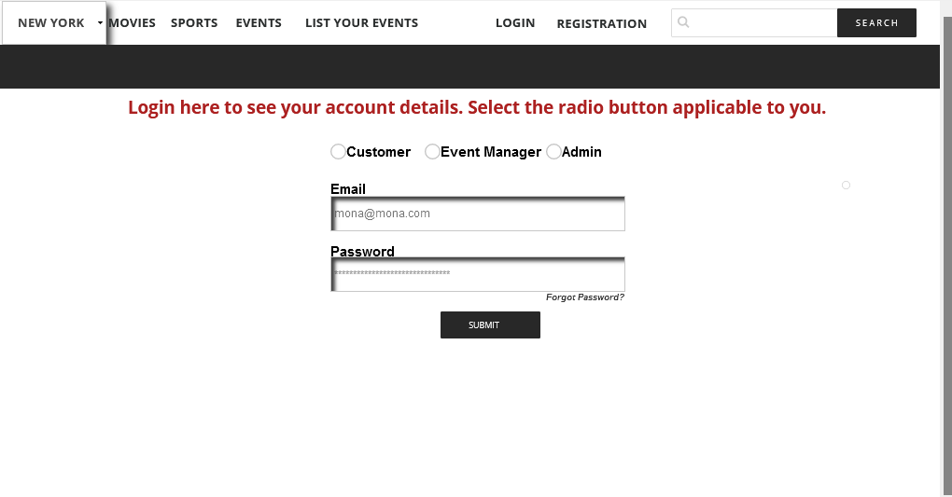

Admin landing page

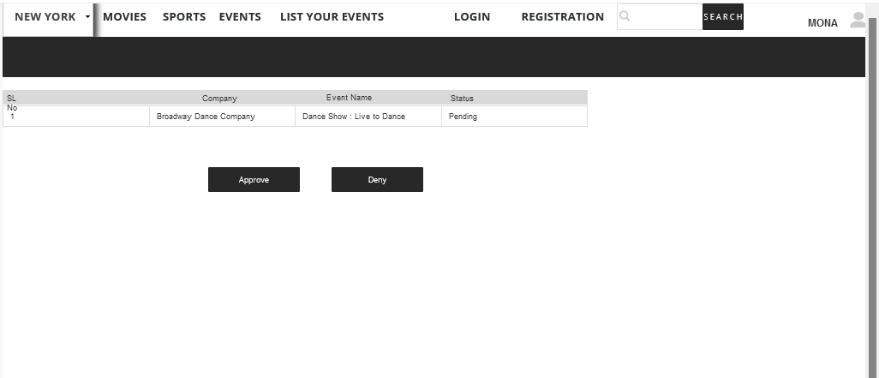

Admin approves the event

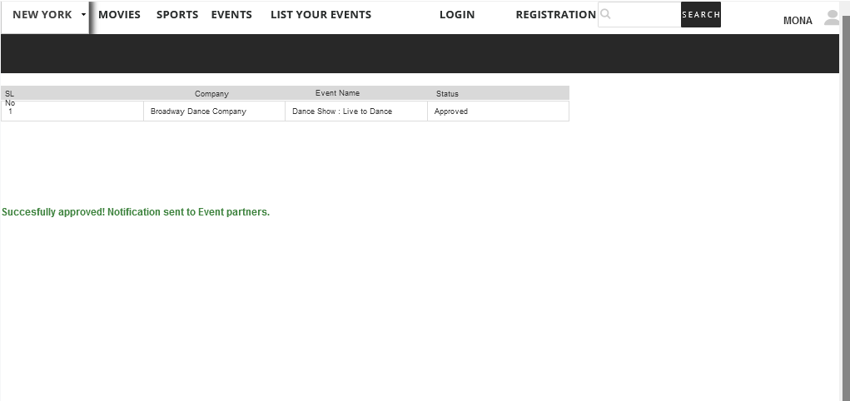

Admin denied event

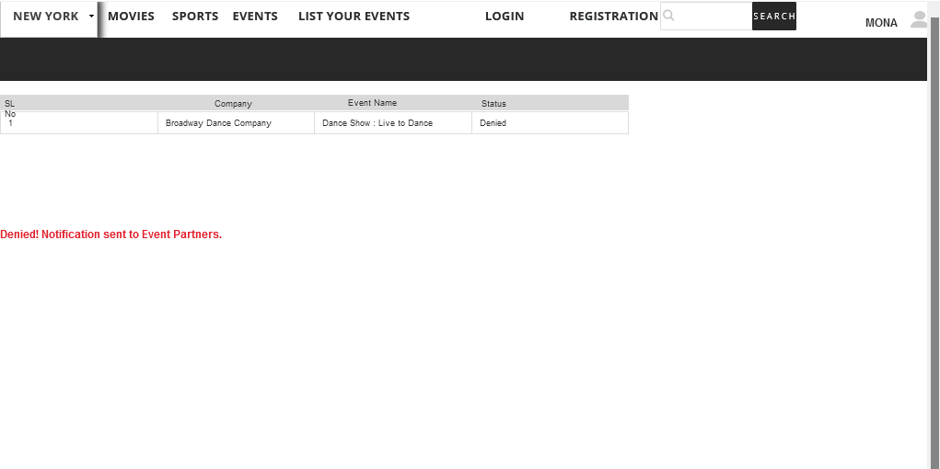

Event page (for New York city)

Features:

According to the city selected in dropdown, the events display

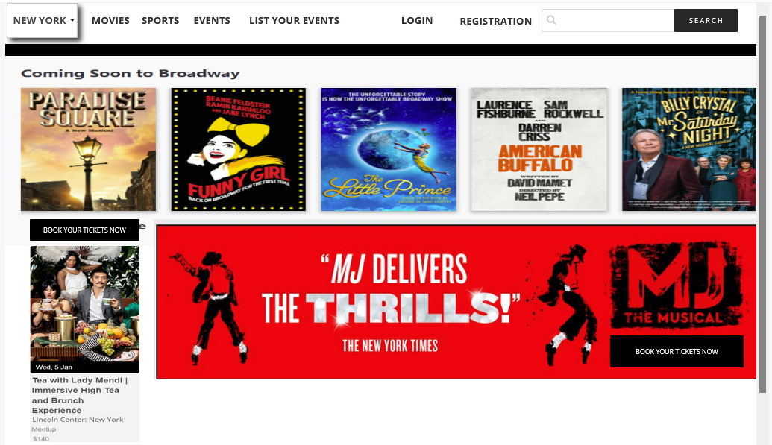

Home page (for Santa Clara city)

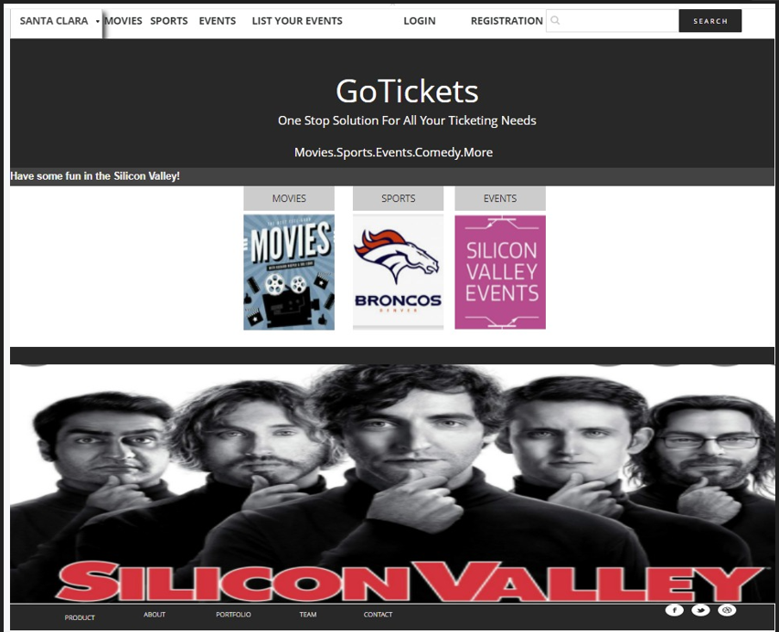



## Program Structure chart

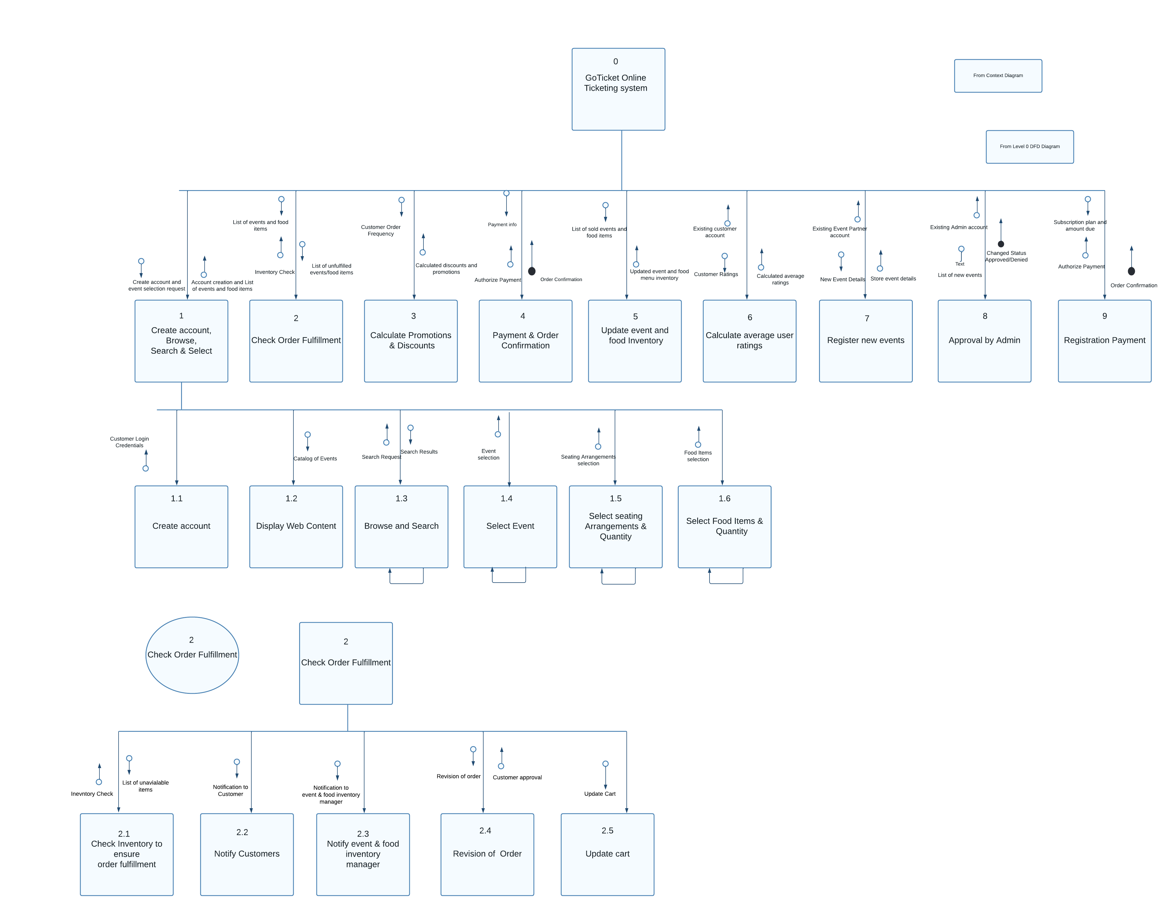

3

Calculate Promotions and Discounts

4

Payment and Order Confirmation

5

Update Event and Food Inventory

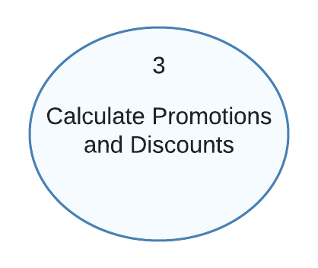

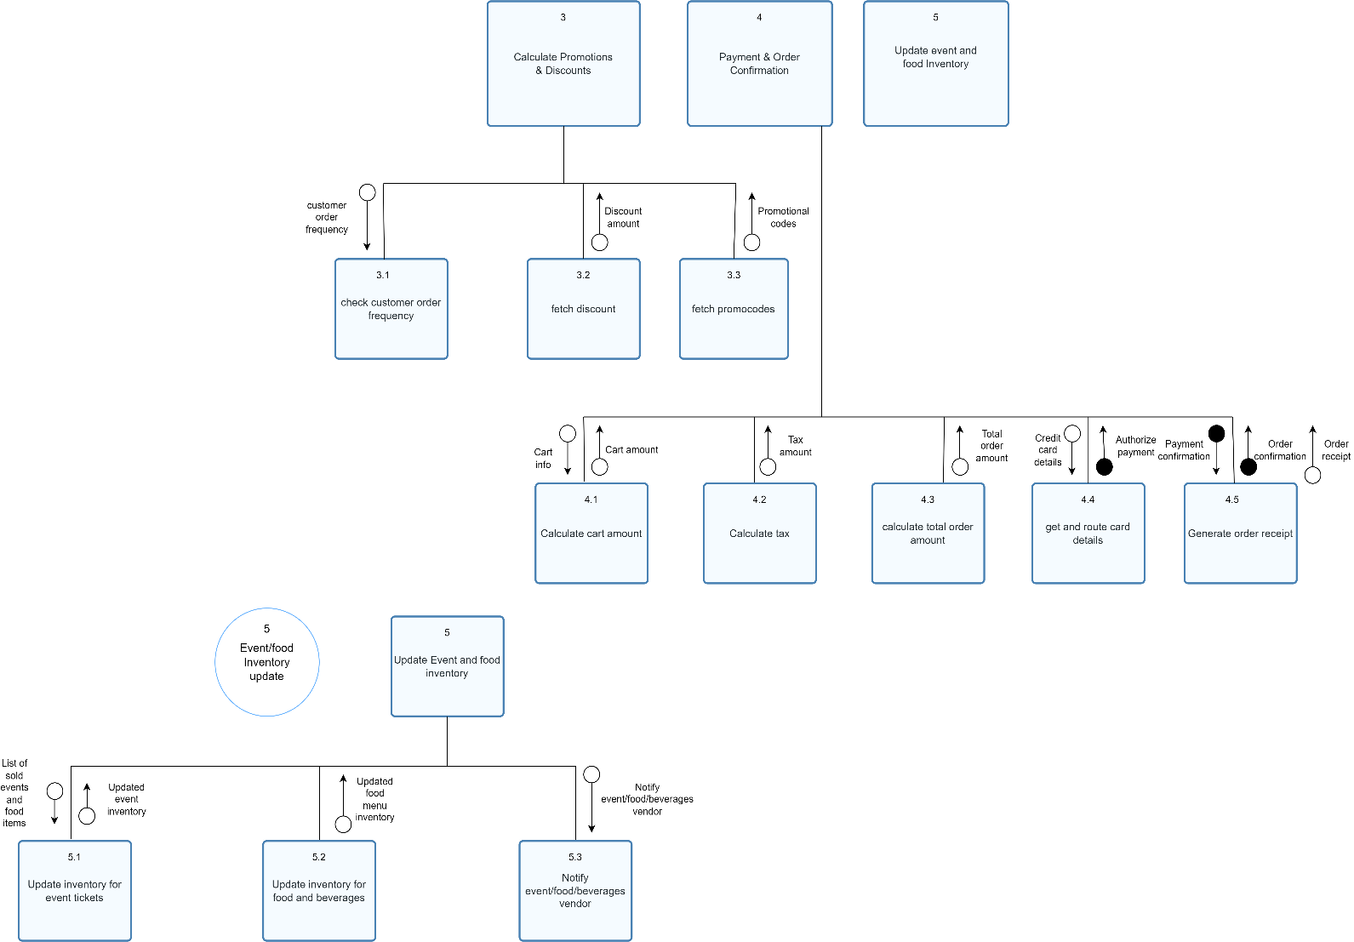

7

Register New events

6

Calculate average customer ratings

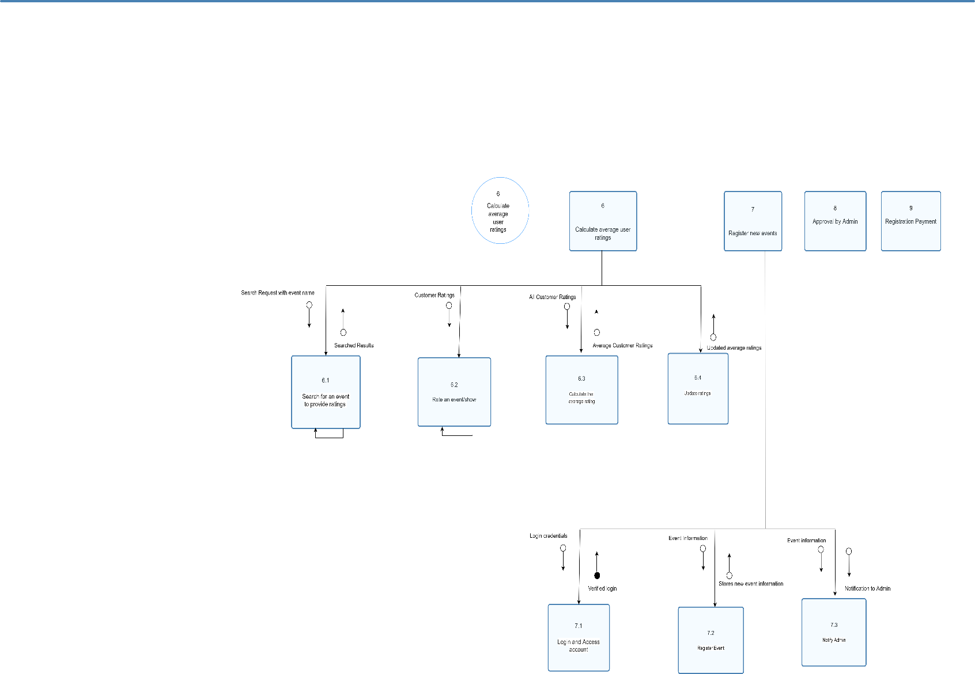

9

Registration Payment

8

Approval by Admin

**Note : To view the above diagram better, please find the attached html document **

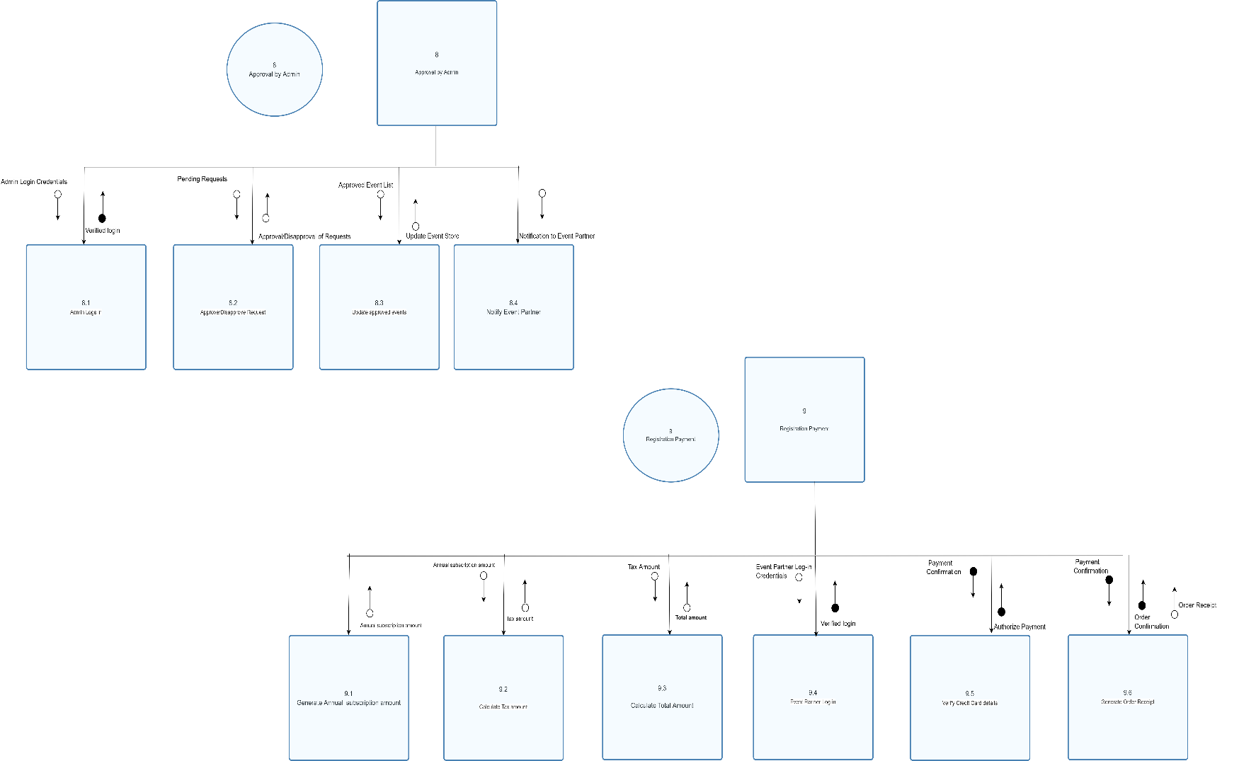

**Note : To view the above diagram better, please find the attached html document **



Future Scope for Improvement

we would like to add few points to explain future scope: -

* The traffic from users who just want to browse through the website and not buy tickets to any event could be managed better.
* If in future we are able to apply Machine learning to predict a user’s preferences, we could customize the event page for each user after they log into the system. This would in turn result in strengthening one to one connection with the brand.
* In order to prevent customers from unsubscribing, we can build automated campaigns for different user segments based on their order history.



## Conclusion

We have built our project based on the core principles of system analysis and design. Using problem-solving strategy, that includes glimpsing at the more extensive system, we were able to break our project into different parts based on different players and sorting out how they work to accomplish a single objective.

The crux of effectively building a system with the right organization of data is to understand how different players view it.

It can be done if requirements are defined in terms of a clear understanding of the inherent structure of the enterprise's data.

So, in conclusion, we can say that system analysis involves significant stages in the growth of any system by detailing the requirements that satisfy present requirements along with alterations in the future.